**Lesson 6 Test the ultrasonic module**

**Table**

1. Notes: 1

2. What do you need to prepare 1

3. How the Ultrasonic Module Works 2

4. Wiring 3

5. Upload code and test 4

6. Code 7

7. Any questions and suggestions are welcome 8

# Notes:

Ultrasonic Distance Sensor module supports a contactless detection within a distance of 2cm-400cm. It contains an ultrasonic emitter, receiver and control circuits.

1. The module is not suggested to connect wires when power is on. If you have to do so, please first connect the GND and then other pins; otherwise, the module may not work.

2. During the ranging, the area of the targeted object should be no less than 0.5cm and the surface facing the module should be as flat as possible; otherwise the result may be inaccurate.

# What do you need to prepare

|  |  |  |  |
| --- | --- | --- | --- |
| **Components** | **Quantity** | **Picture** | **Remark** |
| USB Cable | 1 |  |  |
| Control board | 1 |  |  |
| Ultrasonic Sensor Module(HC-SR04) | 1 |  |  |
| 4 Pin wire | 1 |  |  |

# 3. How the Ultrasonic Module Works

The ultrasonic ranging module usually has four pins, namely VCC, GND, Echo and Trig. The HC-SR04 can provide a non-contact distance sensing function of 2cm-400cm, and the ranging accuracy can reach 3mm; The module includes an ultrasonic transmitter, receiver and control circuit. The basic working principle is as follows:

Use IO port TRIG to trigger distance measurement, and give a high level signal of at least 10us.

The module automatically sends eight 40khz square waves, and automatically detects whether there is a signal return.

There is a signal return, and a high level is output with the IO port ECHO. The duration of the high level is the time from emission to return of the ultrasonic wave.

The principle of distance detection by ultrasonic ranging sensor: the method of detecting distance by ultrasonic is called echo detection method, that is, the ultrasonic transmitter emits ultrasonic waves in a certain direction, and the timer starts timing at the same time as the launch time. The ultrasonic waves propagate in the air and encounter obstacles on the way. When the object surface (object) is blocked, it will be reflected back immediately, and the ultrasonic receiver will immediately stop timing when the reflected ultrasonic wave is received. The propagation speed of ultrasonic waves in the air is 340m/s. According to the time t recorded by the timer, the distance s from the launch point to the obstacle surface can be calculated, namely: s=340t/2. Using this principle of ultrasound, the ultrasonic ranging module is widely used in practical applications, such as car reversing radar, unmanned aerial vehicle, and smart car.

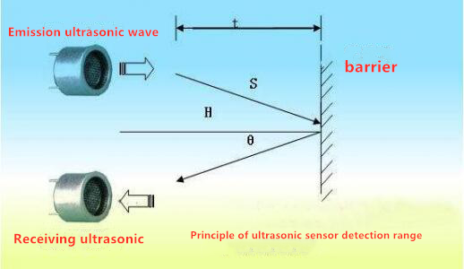

# 4. Wiring

The wiring of hardware as below,in this lesson, we use D12 of Atmega328p to connect with Echo pin of ultrasonic ranging module,use D13 of Atmega328p to connect with Trig pin of ultrasonic ranging module.

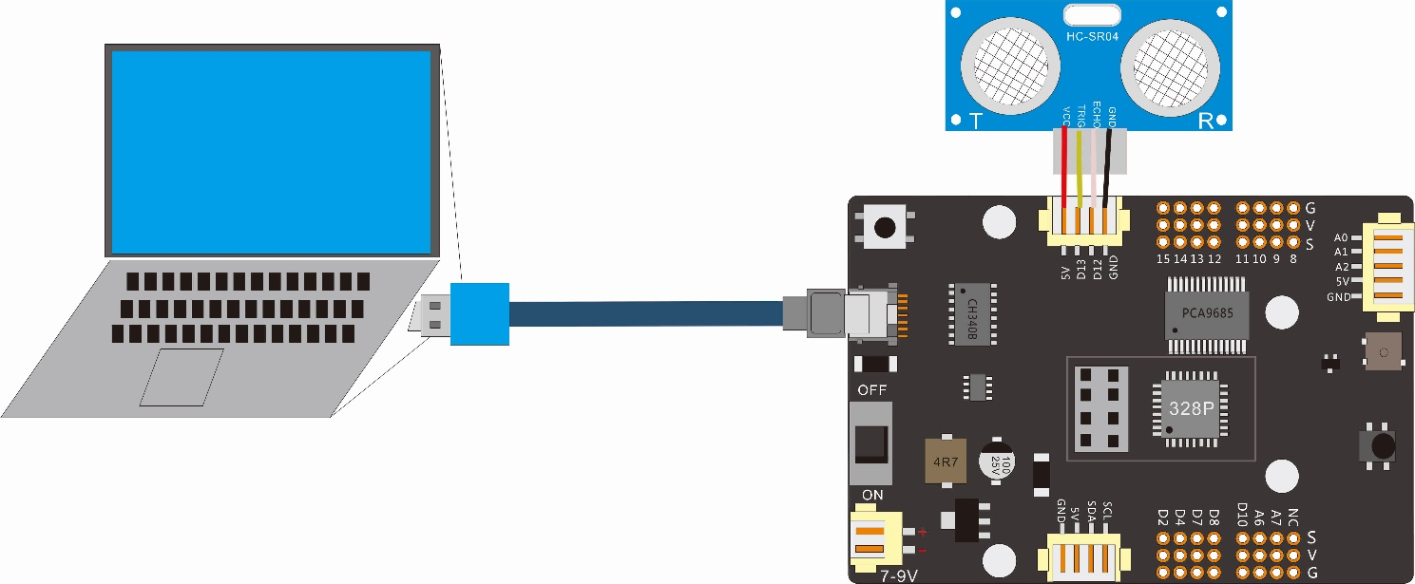

In this lesson will use the ultrasonic sensor module to detect the distance between the obstacle and module and show the detection distance sensed on the serial monitor of Arduino IDE.

Because the power of the ultrasonic Sensor is relatively small, it can be powered by the computer with a USB cable, and no external 18650 battery is needed in this lesson.

|  |  |
| --- | --- |
| Corresponding wiring between the ultrasonic sensor and the control board | |
| Connector of the ultrasonic sensor | X4 Connector of the control board |
| Vcc | 5V |
| Trig | D13 |
| Echo | D12 |
| Gnd | GND |

# Upload code and test

The code used in this lesson is placed in this folder：“ E:\CKK0002-master\Tutorial\sketches”

5.1 Double-click the Arduino IDE shortcut on the desktop to open it

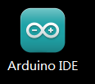

5.2 On the Arduino IDE interface, click "File" --- "open"

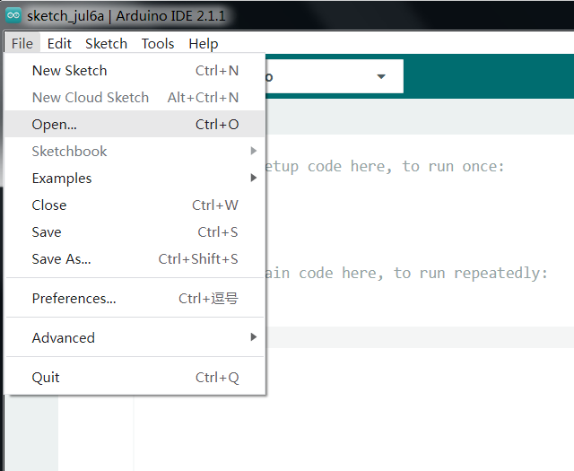

* 1. Select the code in the folder named 4_1_ultrasonic_test：

E:\CKK0002-master\Tutorial\sketches\ 4_1_ultrasonic_test

Then click "open" .

5.4 Select the board "Arduino UNO"and Port "COM3" (COM port is commonly known as an input output port for a device normally PC which enables communication between Arduino and PC. You can check your arduino com number in device manager, the com port of our arduino board is recognized as COM3)

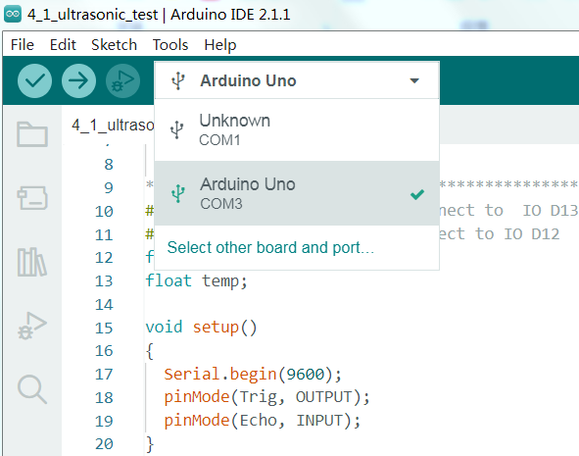

5.5 Click compile button，successfully compiled the code will display “Done compiling”

5.6 Before uploading the code, turn the ESP-01 switch on the control board to the side away from the "ESP-01" silk screen.

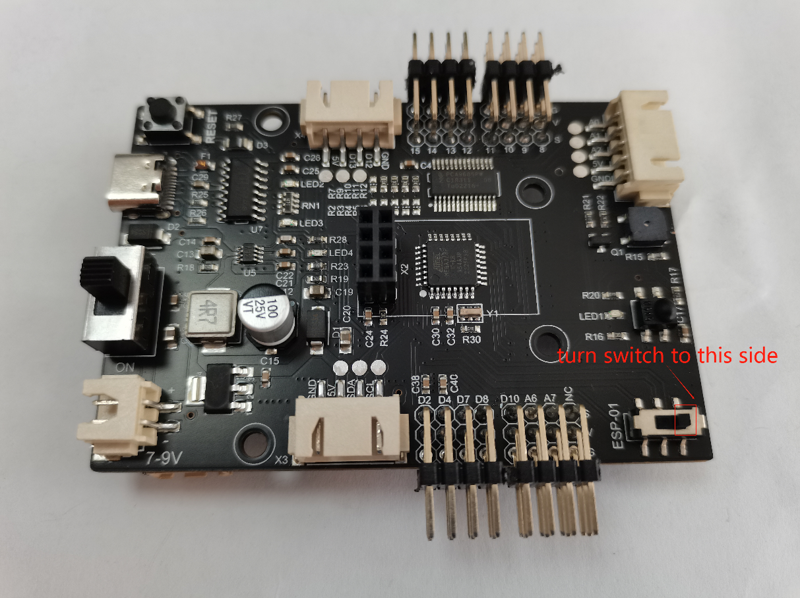

5.7 Click upload button，successfully uploading the code will display “Done uploading”. When code is uploaded successfully, the program starts to run. Click and open Serial Monitor on the IDE, its baud rate is set to 9600, and you can see the distance information "Distance = xxx cm" printed out in the window.

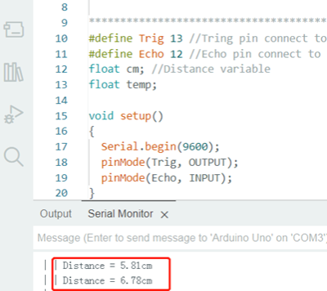

# 6. Code

**4_1_ultrasonic_test：**

#define Trig 13 //Tring pin connect to  IO D13

#define Echo 12 //Echo pin connect to IO D12

float cm; //Distance variable

float temp;

void setup()

{

  Serial.begin(9600);

  pinMode(Trig, OUTPUT);

  pinMode(Echo, INPUT);

}

void loop()

{

  //Send a short, low-high-low pulse to the Trig

  digitalWrite(Trig, LOW); //Send a low level to Trig (initialize)

  delayMicroseconds(2);

  digitalWrite(Trig,HIGH); //Send a high level to Trig

  delayMicroseconds(10);

  digitalWrite(Trig, LOW);

  temp = float(pulseIn(Echo, HIGH)); //Store the echo wait time

  //The pulseIn function waits for the pin to become HIGH,

  //starts calculating the time, and then waits for the pin to become LOW and stops timing

  //The speed of sound is 340m/1s converted to 34000cm / 1000000μs = 34/1000

  //Because it's one way to send to receive, we only need one way, so ➗2

  //Distance (cm) = (Echo time * (34/1000)) / 2

  //The simplified calculation formula is (echo time * 17)/ 1000

  cm = (temp * 17 )/1000; //Convert echo time to distance cm

  Serial.print(" | | Distance = ");

  Serial.print(cm);//The output distance of serial port is converted to cm

  Serial.println("cm");

}

# 7. Any questions and suggestions are welcome

Thank you for reading this document!

If you find any errors and omissions in the tutorial, or if you have any suggestions and questions, please feel free to contact us:

[cokoino@outlook.com](mailto:cokoino@outlook.com)

We will do our best to make changes and publish revisions as soon as possible.

If you want to learn more about smart cars, robots, learning kits and other technology products from us, please bookmark and pay attention to our website:

<http://cokoino.com/>

We will continue to launch interesting, cost-effective, innovative, user-friendly products.

LK COKOINO